OVERALL PROGRAMME EVALUATION REPORT
SEP Scale Alumni Masterclass Module 1 Tanzania (11th May 2026 - 15th May 2026)
No. of Respondents: 197
No. of Participants: 197
Response Rate: 100%
--------------------------------------------------

Faculty Reports

Dr. Isaac Muiruri Gachanja - Business Plan reviews
Evaluation Parameter | (%) Individual Score | (%) Programme Average
Punctuality (Commencement and Completion of Sessions) | 95 | 92
How well do you understand the core concepts presented? | 95 | 88
Rate your confidence in applying the new skills learnt | 88 | 85
Degree of Faculty preparedness for the sessions | 96 | 90
Content and methodology of the program | 96 | 90
Quality of class and group discussions | 95 | 89
The information presented in the course is relevant to my work (ministry) | 98 | 92
Average scores | 95 | 89

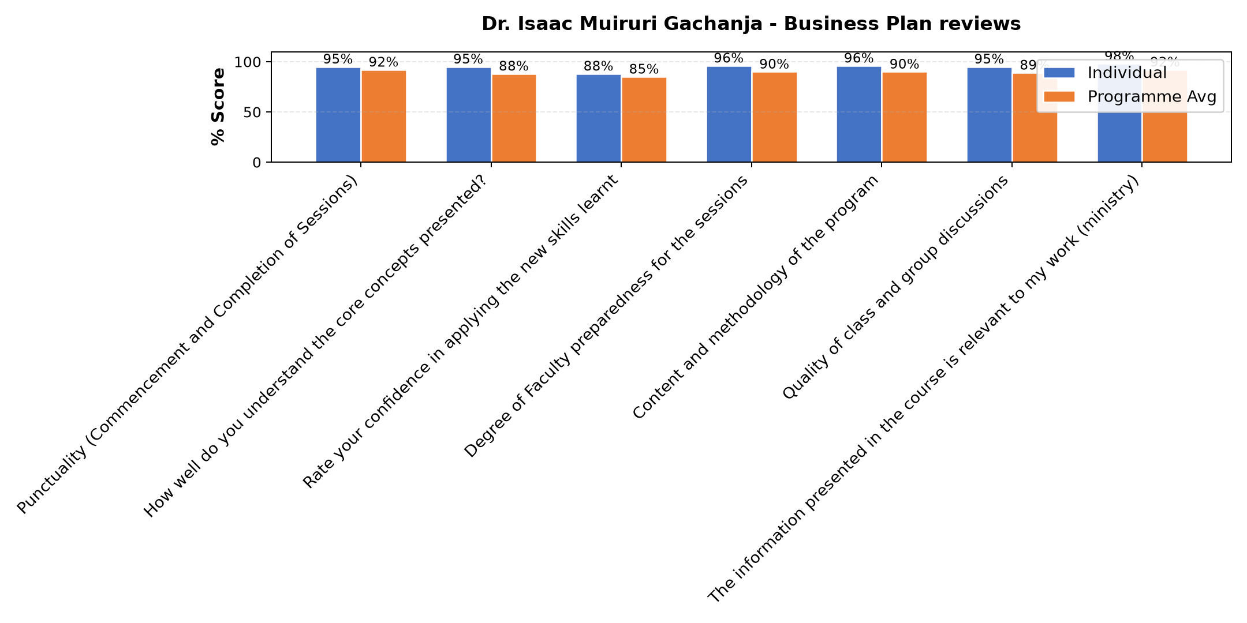

Comments & Feedback
- • Network
- • The barries might prevent me to apply that i learned is Lack of capital, limited experience, and fear of risks may prevent me from applying what I learned about business plan reviews.

Dr. Adriana Lyamba - Customers and competitor evaluation || Market potential evaluation || Customers, competitors and market planning
Evaluation Parameter | (%) Individual Score | (%) Programme Average
Punctuality (Commencement and Completion of Sessions) | 98 | 92
How well do you understand the core concepts presented? | 86 | 88
Rate your confidence in applying the new skills learnt | 87 | 85
Degree of Faculty preparedness for the sessions | 92 | 90
Content and methodology of the program | 90 | 90
Quality of class and group discussions | 86 | 89
The information presented in the course is relevant to my work (ministry) | 92 | 92
Average scores | 90 | 89

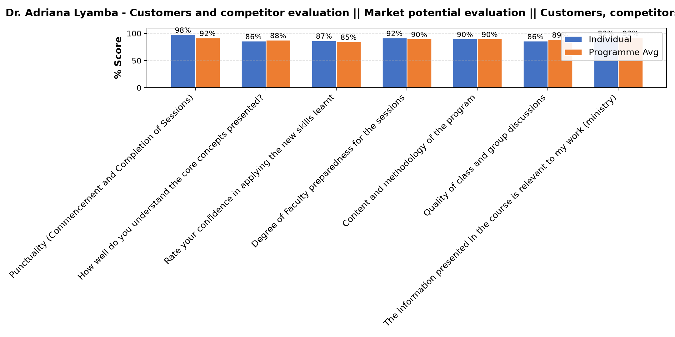

Comments & Feedback
- • The lesson was so good
- • The barrier would be lack of enough skills for segmentation and capital. Customer segmentation needs research and data collection.
- • Some barriers that might prevent me from applying what I learned about customer segment and competitor evaluation include limited time to conduct proper analysis, lack of enough data about customers and competitors, and limited resources to implement marketing strategies. Another challenge may be resistance to change within the organization and difficulty in consistently updating market information.
- • Failures to categorize customers in segments
- • Network problem
- • Workload
- • How to manage custommers
- • Sometimes a network
- • Fear of taking risk
- • To look the customer needs according to the environment
- • To change the mind set of those who think they know everything.
- • Uwezekano wa kukosa ushirikiano wa wale nitakoenda kuwashiirikisha
- • Good customer segimentation might be challenging in school because parents' preferences change with examination results. This may make it difficult to maintain accurate data.

Dr. Joan Wanjiku Ndung'u - Gitahi - Reflect on Vision and Mission || Reflect on charism || Identify alignment to social enterprise
Evaluation Parameter | (%) Individual Score | (%) Programme Average
Punctuality (Commencement and Completion of Sessions) | 91 | 92
How well do you understand the core concepts presented? | 85 | 88
Rate your confidence in applying the new skills learnt | 86 | 85
Degree of Faculty preparedness for the sessions | 89 | 90
Content and methodology of the program | 88 | 90
Quality of class and group discussions | 89 | 89
The information presented in the course is relevant to my work (ministry) | 88 | 92
Average scores | 88 | 89

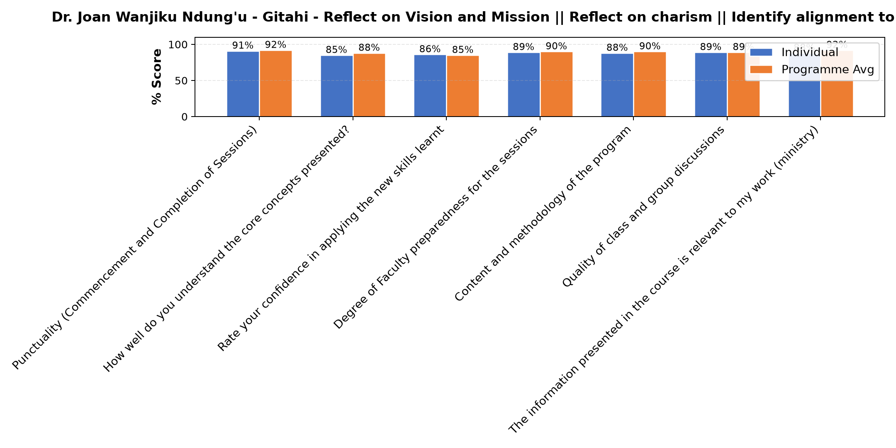

Comments & Feedback
- • Network
- • I have understood well the subject, and the period was so nice
- • Lack of clear goals, insufficient of funs or resources and negative attitudes among members.
- • Some times a network is not good.
- • Learning conditions
- • Transport to visit in all areas
- • May be time and space
- • The major barrier preventing me from applying t the knowledge I gained today is making people understand the reality that even if we operate guided by the spirituality, charism, mission, vision and values, yet we need to move with the fast moving and expensive world of science and technology. Some parents may demand me to be more compassionate and take advantage of not paying school fees knowing that we operate as religious.
- • Only network
- • Network problem
- • Poor planning
- • Welll organized
- • Barriers that may prevent me from applying what I have learned include lack of time due to many responsibilities, resistance to change and preference for familiar methods, fear of making mistakes or lack of confidence, and limited support from colleagues or the work environment. Other challenges include lack of necessary resources or tools to implement the new knowledge, information overload that makes it difficult to remember everything, and training that is not directly related to daily tasks or is not reinforced through continuous practice and follow-up.
- • The major barrier is making the administration of our SE to understand and to give room for the things I need to change from how we have been doing to what I have learnt today.
- • Time

Dr. Joan Wanjiku Ndung'u - Gitahi - Reflection and leadership and teams (employees)
Evaluation Parameter | (%) Individual Score | (%) Programme Average
Punctuality (Commencement and Completion of Sessions) | 97 | 92
How well do you understand the core concepts presented? | 93 | 88
Rate your confidence in applying the new skills learnt | 84 | 85
Degree of Faculty preparedness for the sessions | 91 | 90
Content and methodology of the program | 90 | 90
Quality of class and group discussions | 91 | 89
The information presented in the course is relevant to my work (ministry) | 93 | 92
Average scores | 91 | 89

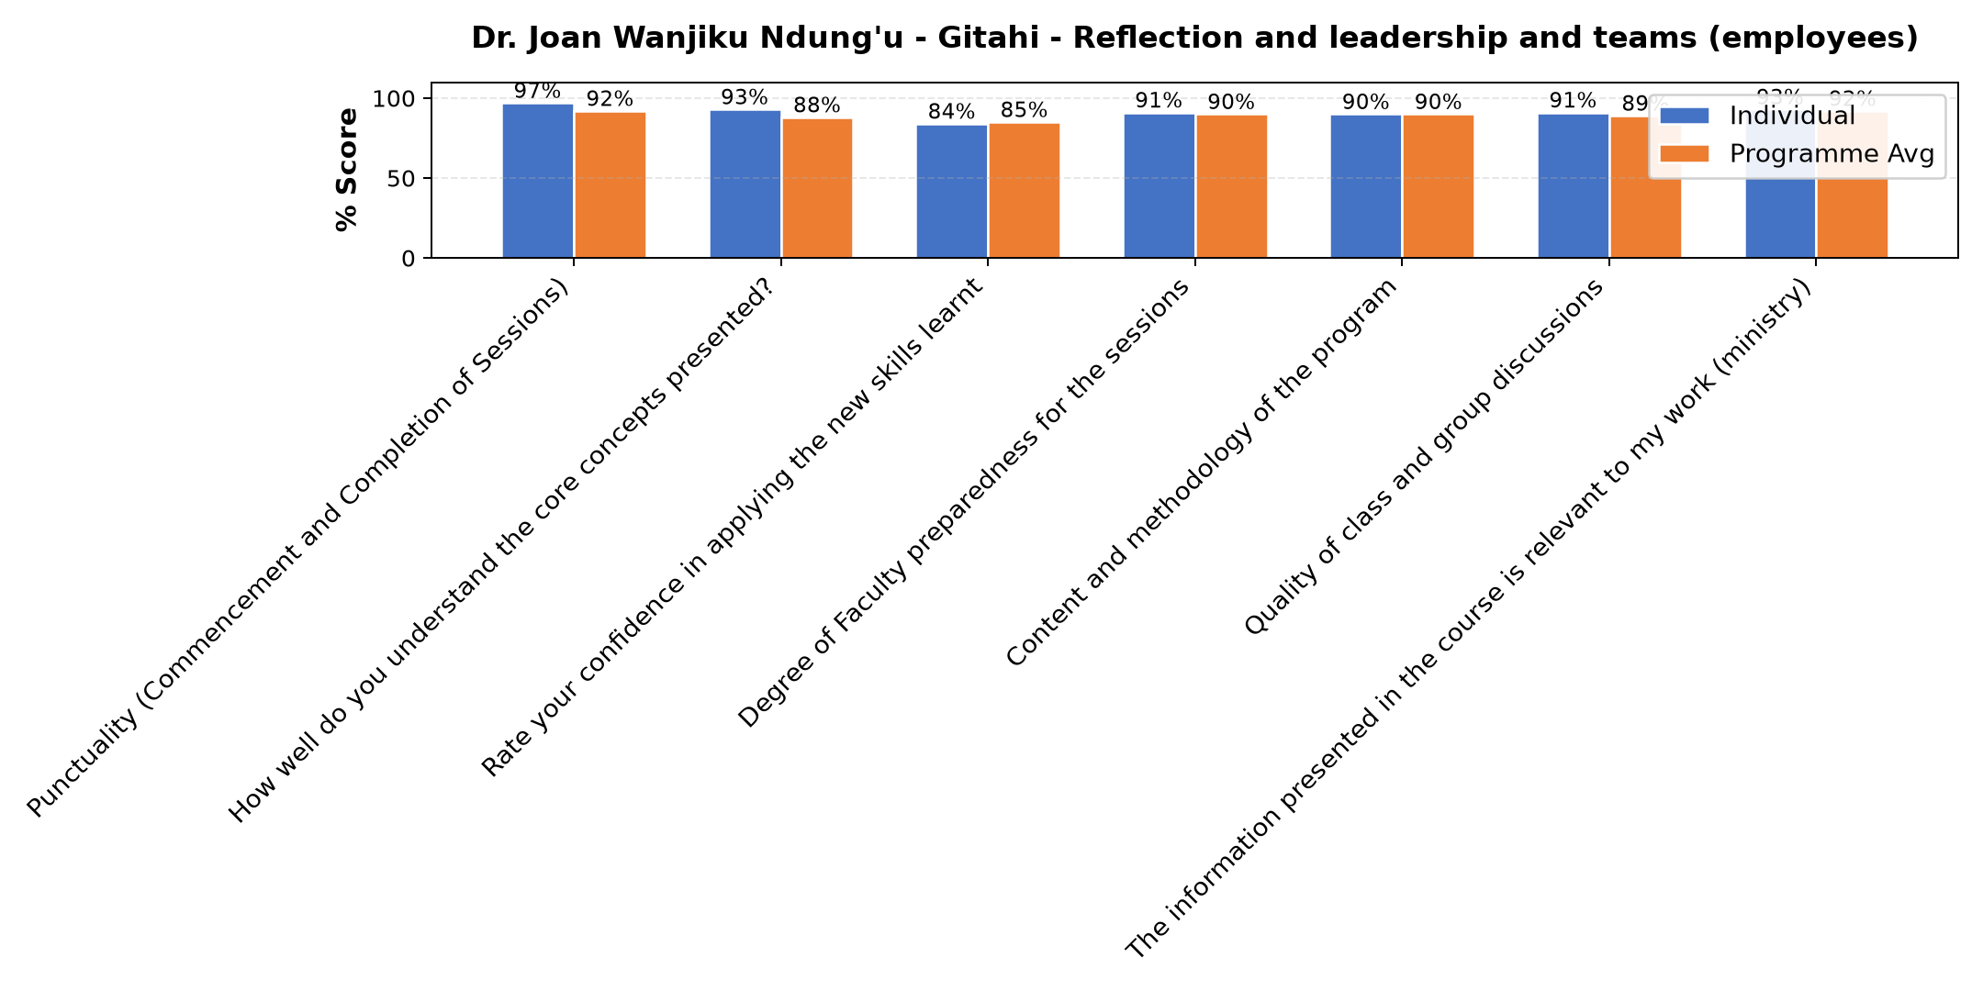

Comments & Feedback
- • Is just my behavior
- • Some barriers that might prevent me from applying what I learned include my tendency to stick to one communication style instead of adapting to different personalities. Also, work pressure or lack of time may make me forget to apply the appropriate communication approach. In addition, lack of enough practice may make it difficult for me to adjust quickly in real situations.
- • The questions asking only one person at whole period
- • By knowing my self and to know one another and to appreciate what others do
- • No
- • The challenge would be balancing the colours and be able to cope with others.
- • Different personalities but I will try to aply the knowledge I learnt today
- • Nothing
- • The possible barrier is trying to make other people behave as I wish, based on the dominant colour. There might be disappointments when things go differently.
- • May be In connection with my workers otherwise there is no barrier
- • Kushindwa kusimama katika nafasi yangu mimi mwenyewe

Dr. Isaac Muiruri Gachanja - Reflection of SEP Learning
Evaluation Parameter | (%) Individual Score | (%) Programme Average
Punctuality (Commencement and Completion of Sessions) | 77 | 92
How well do you understand the core concepts presented? | 81 | 88
Rate your confidence in applying the new skills learnt | 82 | 85
Degree of Faculty preparedness for the sessions | 81 | 90
Content and methodology of the program | 84 | 90
Quality of class and group discussions | 82 | 89
The information presented in the course is relevant to my work (ministry) | 87 | 92
Average scores | 82 | 89

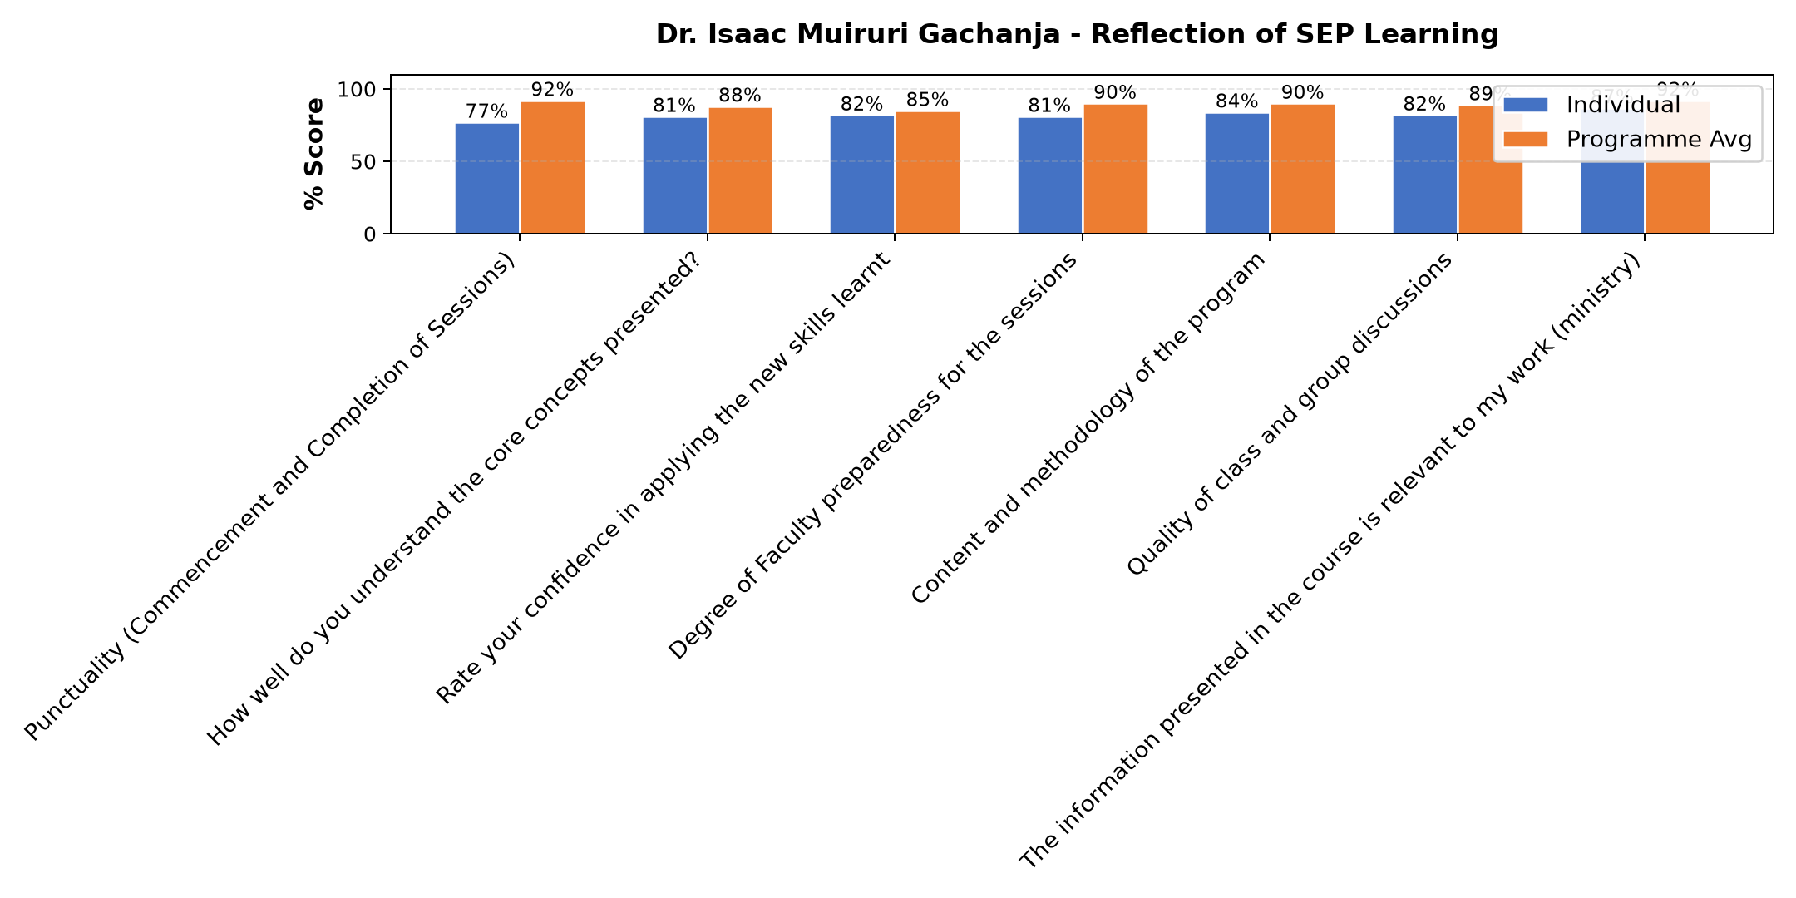

Comments & Feedback
- • Network
- • Network problem sometimes I didn't get well the discussion
- • Lack of money become a big barrier in running Instution.
- • Network were not stable
- • Some times a network.
- • Lack of sufficient resources to improve our project, Challenges in obtaining technology or network services. And also Difficult business environments such as competition or economic challenges. But I am very grateful for this education we received that we continue to use and it brings us greater benefits.
- • The major challenge that might prevent me from applying what I have learnt is how to accomplish the SE goals within a limited budget. The world moves so quickly but for us who live in the villages we are still very far. At the same time we need to move with signs of time. Now, how do we move with time without enough capital?
- • Fear of taking risk
- • There is no barrier
- • Lack of enough resources or materials
- • Poor response from the donours
- • Lack of getting enough chicks in timeMr
- • I learn on how to manage ECONOMIC INTERPRICES
- • Economic factors
- • Barriers which could hinder or prevent us from applying what we learned might be lack of enough chicks and deases which always appear.

Department Reports

Are there any other comments and/or suggestions that you may want to add?

Comments & Feedback
- • I suggest to do every month.
- • We sincerely thank you for this programme. We kindly request that, if possible, it be conducted during daytime hours or school holiday periods to reduce challenges for participants who are working, such as teachers.
- • The class can continue

Further Comments

Comments & Feedback
- • The session was very informative and inspiring. The facilitator explained the concepts clearly and encouraged participation. Thank you for the valuable training. And Also Iam very grateful for this session because I learned a lot. I also learned from my fellow sisters through the way they presented the successes and challenges of their projects, which gave me valuable lessons and inspiration. I would also like to sincerely thank Brother Venance for his excellent coordination and guidance throughout the session. Thank you to everyone for this wonderful learning opportunity. May God Bless you all.
- • The presentation of Dr. Isaac was very clear and understandable.
- • Everything is presented good and understandable.
- • No
- • Fund to support the project to grow to larger scale
- • It would be better if clear guidelines is given to the question being asked so that Sisters can provide precise and clear answers. Thank you
- • Internet problem
- • Sharing was inspiring
- • Mr. Isac explained very well today's leason althogh there was internet problem.
- • I like to learn more on how to accumulate capital
- • Thank you for zoom platform lat us find together alternative net work in order to face challenges of communication system.
- • Mr Isaac Gachanja has done very well even though there was Networks problem. God bless you all for wverything you have prepared for us
- • I thinks God for giving us this opportunity of sharing this experience among us.
- • The lesson was good
- • Well presenters .
- • We need to get more knowledge so as to raise our social enterprises
- • I hope will find another time to learn again.
- • The lesson was well prepared.
- • Good teacher knows on how to teach
- • Thank you very much the lessons was excellent.
- • Thanks a lot continue with the next session
- • Thank you Dr Joan Gitahi for your wanderful session. God bless
- • The presentation was very relevant and clear. Thanks a lot and God bless you Dr. Joan🙏🙏
- • Continue with the session
- • Laxk of enough fund
- • It's helpful
- • I am very grateful for this training because it has helped me better understand Vision, Mission, and the Charism of my social work. The training has given me insight on how to connect my service work with community development. Thank you so much 🙏🙏
- • The change is possible but we need time and some resources to put into actions and be able to encorporate our charism, mission and vision in our daily activities at the SE.
- • Very inspiring and well presented. It was too good.

Further Comments

Comments & Feedback
- • I will try to change .and the session was good today thank you Dr. Joan God bless you.
- • I am grateful for this session because it has helped me understand different personality styles and how to communicate with them effectively. I have learned that flexibility and respecting differences are very important for teamwork and success. I will do my best to apply this knowledge in my daily work to improve cooperation and performance. Also i like to thank Dr. Joan for teaching us so well. May God bless her abundantly. And I would like also to thank Bro.Venance for managing and coordinating this activity very well. Thank you very much, and may God bless you all.
- • Avoid dealing with one person
- • Well presented. appreciated. And grateful
- • The lesson was so clear for me, thanks a lot Dr. Joan, well done
- • A word appreciation to the facilitator and organising team 🙌
- • I have enjoyed the insight Discovery.The lesson was Excellent. Thank you very much Dr.Joan Ndug'u Gitahi.
- • Thanks Dr. Joan for a very good presentation and for your time.
- • The Facilitator was excellent
- • The lesson was well understood to me
- • Knowing my colours and that every person has her/his own colours, I need to appreciate others and make effort to raise the colour which seems weak within myself.
- • I thank God for you all, may the good Lord reward you.
- • Thank very much Dr. For this reflection

Further Comments

Comments & Feedback
- • The presentation of Dr. Adriana was very good and stimulating. The only problem is the "how." With the limited capital.
- • We promise to work hard
- • I appreciate the knowledge gained on customer segment and competitor evaluation as it has improved my understanding of how to identify target customers and analyze competition effectively. The session was well delivered and very relevant to my work. I would recommend more practical examples and case studies to enhance understanding and application of the concepts in real-life situations.
- • I have to learn how to obtain customers
- • Well presented
- • This topic very crucial
- • Good presenter in teaching
- • Fund
- • The topic is very crucial to our SE
- • Thank you for everything you prepared for us so yhat we may do our social entreprise in good way. God bless you all.
- • Thank you very much.
- • We promise you to work hard after acquiring knowledge
- • Ni vema sana masista wengi wapate semina hii
- • I appreciate Dr. Adriana for her good presentation and for perseverance.

Overall Evaluation
Evaluation Parameter | (%) Score
Overall program evaluation | 93
Average score | 93

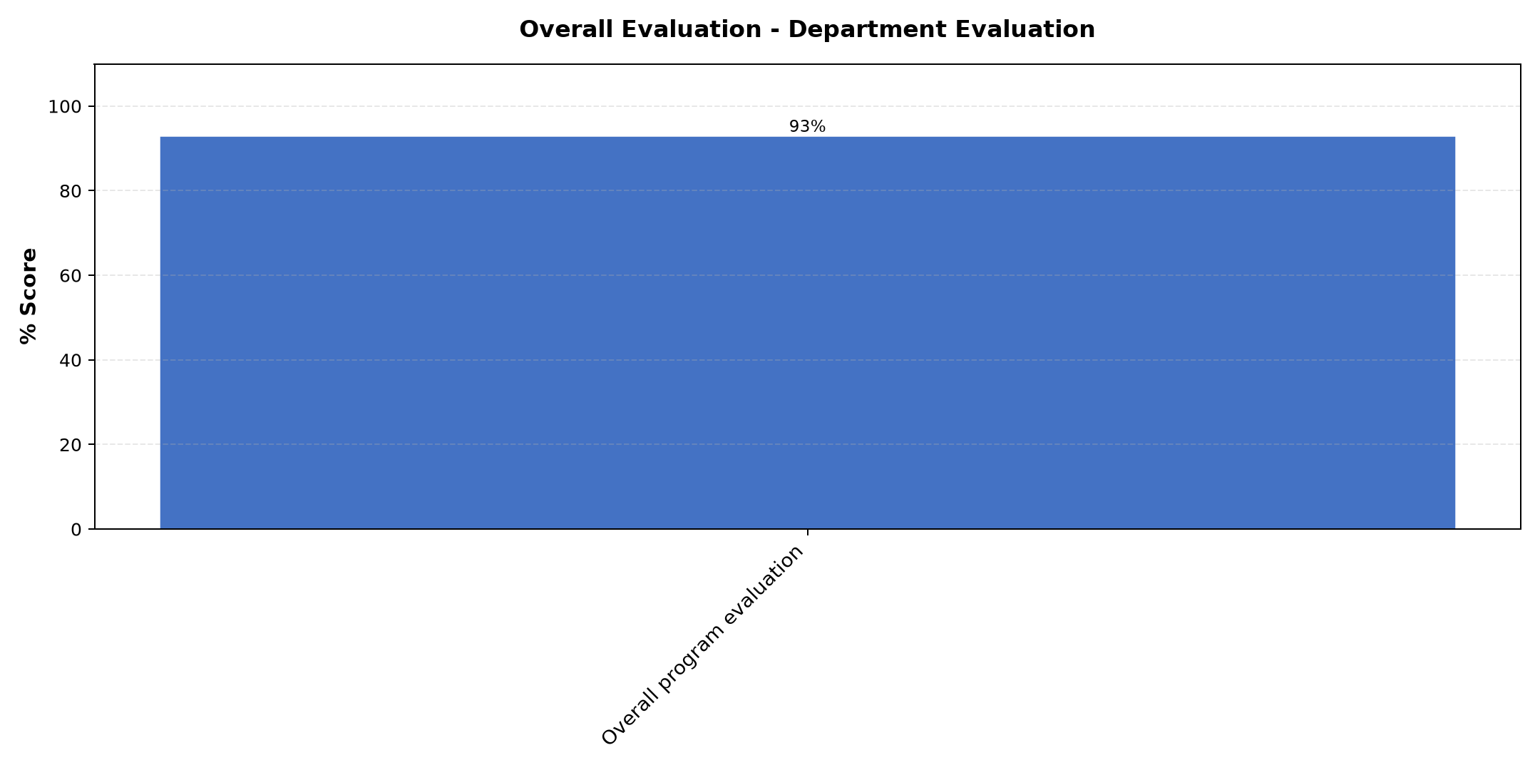

Comments & Feedback
No comments recorded.

Program Manager (Venance Mwakangale)
Evaluation Parameter | (%) Score
Punctuality in sending materials and programme information | 93
Communication skills(verbal and written) | 90
Response to programme enquiries via email, whatsapp and calls | 90
Accessibility and willingness to support when needed | 90
Quality of service / professionalism | 93
Average score | 91

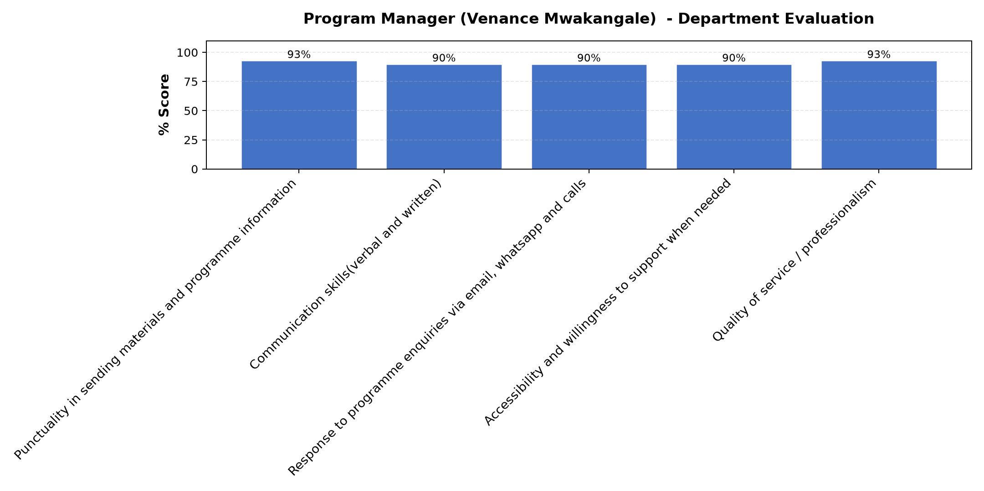

Comments & Feedback
- • Good presentation
- • I would like to sincerely thank all our trainers for this whole week: Dr. Gachanja, Dr. Joan, Dr. Adriana, and Venance for the excellent training you provided us on improving the effectiveness of our projects. May God bless you abundantly. We also pray that God helps us put what we have learned into practice. Thank you very much.
- • No
- • The program was arranged properly
- • No further comments
- • Very good presentation

What attracted you to the programme??

Comments & Feedback
- • I was attracted to the programme because it offered practical knowledge and skills that can help improve my personal and community development acording to our project. I was also interested in learning how to develop and manage successful projects and business plans, as well as gaining new ideas from experienced facilitators and other participants.
- • Four color model
- • Discovery insight
- • Learning through social media
- • Business plann
- • Marketing
- • The way had been delivering by the doctors
- • The skills being instilled and sharing from different congregatio

What topic would you recommend being expanded/improved in this programme’s units?

Comments & Feedback
- • All the topic are good and improved
- • Reflect on vision and mission, Business plan reviews, customers and competitors evaluation and Reflection and leadeship
- • No
- • Business plan reviews
- • This program is good the class must continue in order to produce more in our social enterprises
- • Color
- • Convince relation to SE
- • Buildingsustainabile social Enterprises Aligned with Charism, Mission and Vission.
- • Business plan
- • I would recommend the topic of Business Modal Canvas because I see this topic very important in many areas of doing business.

Which areas in this programme did you find most important to your social enterprise?

Comments & Feedback
- • All the areas of social enterprise
- • The most important areas of the programme for my social enterprise were reflecting on vision and mission, because they helped me understand the purpose and direction of my business. I also found customer and competitor evaluation very useful, as it taught me how to identify my target customers and understand the market better. In addition, leadership and teamwork sessions helped me improve how I work with others and manage responsibilities effectively. The business plan review was also very important because it helped me see the strengths and weaknesses in my plan and how to improve it for better results.
- • Customer segment
- • Reflection on charism and identity alignment to social enterprise.
- • Leadership
- • About color
- • Markketing and how to write convince
- • In all areas .
- • Vision, mission and charism, Leadership and team, business plan
- • For me Supply & demand seemed most important. One of Dr. Isaac's examples of product mix opened my mind because most of the time we mix up products which are not related. At the end of the day we end up wasting time and resources.

Which teaching methods applied in the course did you enjoy/learn from the most?

Comments & Feedback
- • Teachers learning method l enjoyed in learning .
- • I enjoyed the methods the teachers used to engage everyone so that they could participate.
- • Recture
- • Discussion and Question and answers
- • Discussion
- • Participation method
- • Discotion
- • Both interactive interactive and lecture
- • Participatory way of teaching kept the group active.

